LAB ASSIGNMENT 4.2:
Consider the following table: Table: ACCOUNT_TXN
Acc_ID Holder_Name Balance
101 Aman 5000
102 Bhavna 7000
103 Chirag 6000

Perform the following TCL-based SQL script and write the output after each SELECT statement:
INSERT INTO ACCOUNT_TXN VALUES (104, 'Diya', 4000);
SAVEPOINT S1;
UPDATE ACCOUNT_TXN SET Balance = Balance + 1500 WHERE Acc_ID = 101;
UPDATE ACCOUNT_TXN SET Balance = Balance - 1000 WHERE Acc_ID = 102;
SAVEPOINT S2;
DELETE FROM ACCOUNT_TXN WHERE Acc_ID = 103;
INSERT INTO ACCOUNT_TXN VALUES (105, 'Eshan', 3000);
SAVEPOINT S3;
UPDATE ACCOUNT_TXN SET Holder_Name = 'Bhavna Sharma' WHERE Acc_ID = 102;
SELECT * FROM ACCOUNT_TXN;
ROLLBACK TO S2;
SELECT * FROM ACCOUNT_TXN;
INSERT INTO ACCOUNT_TXN VALUES (106, 'Farah', 4500);
SAVEPOINT S4;
UPDATE ACCOUNT_TXN SET Balance = Balance + 500 WHERE Acc_ID IN (101,104);
SELECT * FROM ACCOUNT_TXN;
ROLLBACK TO S4;
SELECT * FROM ACCOUNT_TXN;
COMMIT;
Student Tasks
- Write the output of all 4 SELECT statements in tabular format.
- Identify which rows are permanently saved after COMMIT.
- Mention which operations were undone by:
  - ROLLBACK TO S2
  - ROLLBACK TO S4
- Write the final state of the table after COMMIT.

Answer the following:
What is the difference between ROLLBACK and ROLLBACK TO SAVEPOINT?
Can we rollback to S3 after ROLLBACK TO S2? Why/Why not?
What happens if COMMIT is executed before creating any savepoint?

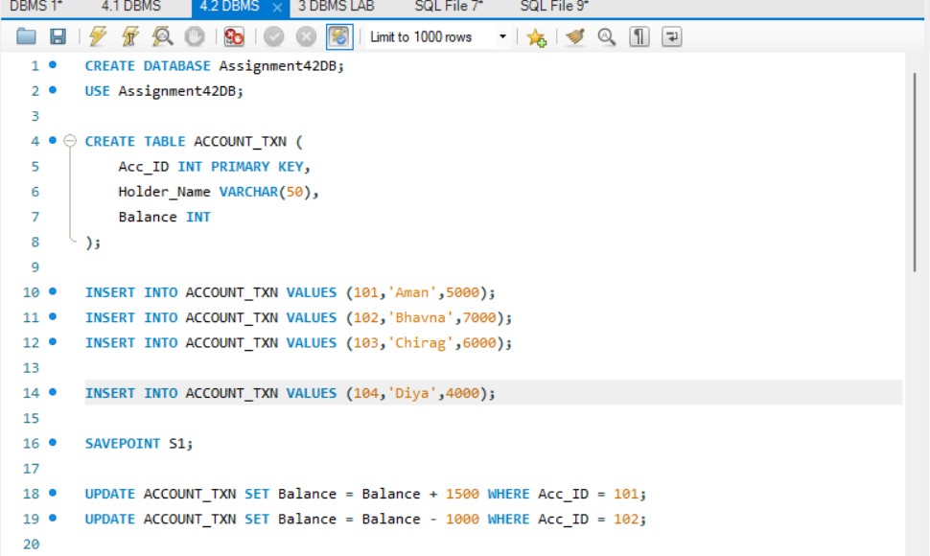
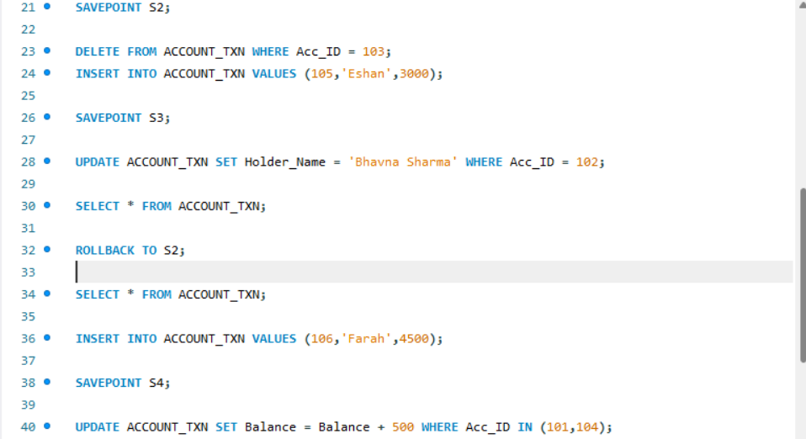


OUTPUT:
